t cancer recurring is difficult for every breast cancer survivor. Living with Metastatic Breast Cancer can be isolating. Judy Erdahl and Camille Scheel are both living with Metastatic Breast Cancer and will share their knowledge of the disease, resources for coping and ways that you can help spread the word on life with "mets."

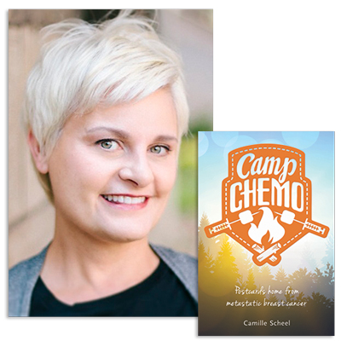
Camille Scheel
Camille Scheel is author of Camp Chemo: Postcards Home from Metastatic Breast Cancer (Beaver's Pond Press: 2015)
Diagnosed with Stage III breast cancer at 38, Camille began blogging about her experiences. When she learned the breast cancer metastasized to her bones in 2012, the blog started up again. Now she knows the cancer is incurable, but continues to live life on her own terms. Camp Chemo is part of the advocacy work she started soon after diagnosis.

As a breast cancer advocate, Camille is passionate about educating others about life with Stage IV breast cancer. Her advocacy work has taken her to national conferences in Philadelphia, Boston and Denver. She is a breast cancer research reviewer for the Department of Defense Congressional Funded Medical Research Program and is a trained Hear My Voice Advocate for Living Beyond Breast Cancer.

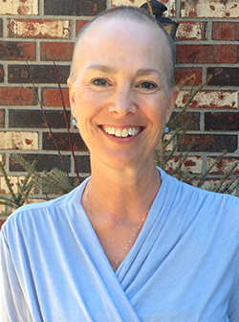
Judy Erdahl
Judy Erdahl has been living with cancer for over 20 years. Judy spent much of her adult life serving families as a licensed parent educator. When Judy’s third round with cancer forced her to retire she turned her energies towards writing and educating others about the real world of stage IV breast cancer. She has shared her story with audiences large and small and is a passionate advocate of metastatic breast cancer research and education.
Judy is a co-founder of “Team Judy” which raises money to support metastatic breast cancer research at the Masonic Cancer Center, University of Minnesota. Judy shares her story of living with metastatic disease to encourage others to learn to live each day with gratitude, compassion and hope. You can find her at PinkisComplicated.com

